AVEH-622

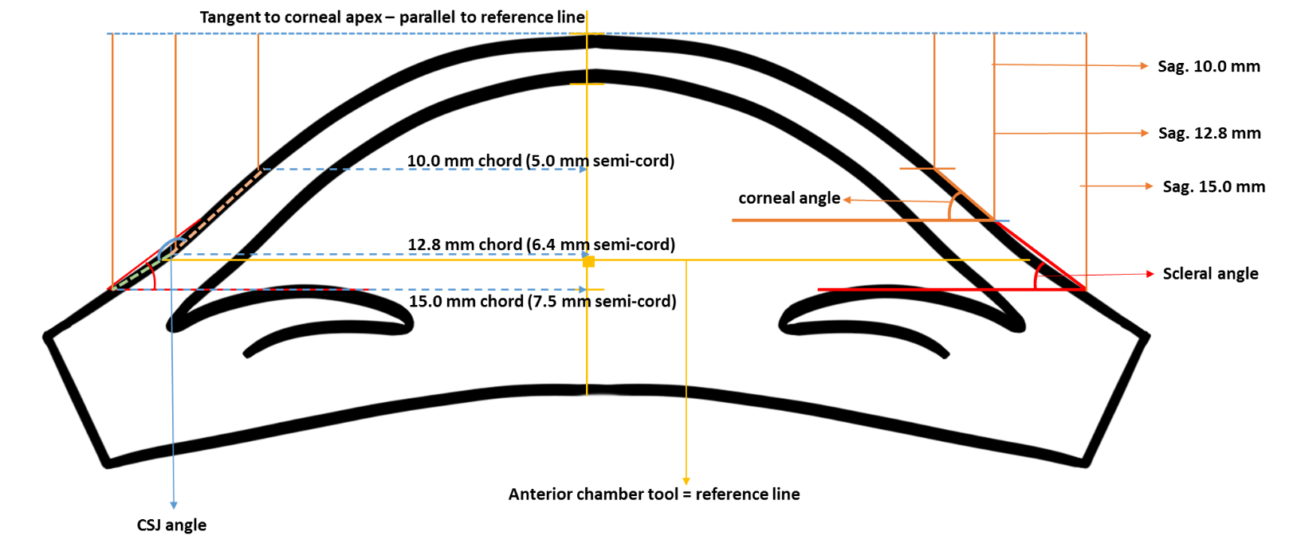
Figure 1. Sagittal height and corneoscleral angle measurements

